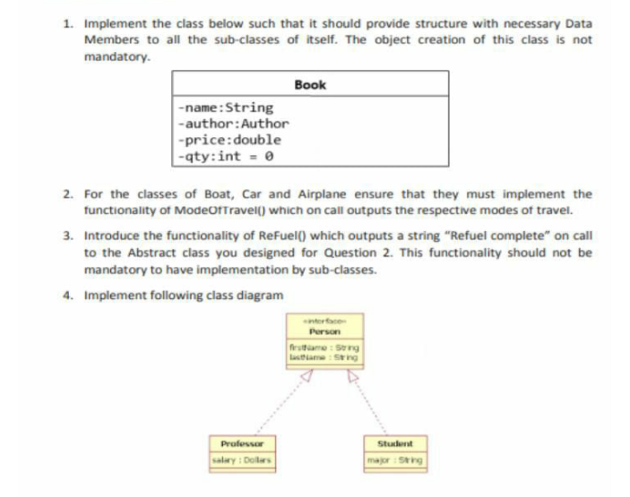

**Q1:**

**Code:**

using System;

namespace Assignment

{

class Program

{

static void Main(string[] args)

{

}

}

abstract class Book

{

private string Author;

private string Name;

private double Price;

private int qty= 0;

public void setName(string name)

{

this.Name = name;

}

public string getName()

{

return Name;

}

public void setAuthor(string author)

{

this.Author = author;

}

public string getAuthor()

{

return Author;

}

public void setPrice(double price)

{

this.Price = price;

}

public double getPrice()

{

return Price;

}

public void setQty(int qty)

{

this.qty = qty;

}

public int getQty()

{

return qty;

}

}

class Name : Book

{

public void Print()

{

Console.WriteLine("NAME OF THE BOOK: " + getName());

}

}

class Author : Book

{

public void Print()

{

Console.WriteLine("AUTHOR OF THE BOOK: " + getAuthor());

}

}

class Price : Book

{

public void Print()

{

Console.WriteLine("PRICE OF THE BOOK : " + getPrice());

}

}

class Quantity : Book

{

public void Print()

{

Console.WriteLine("QUANTITY OF BOOK:" + getQty());

}

}

}

**Q2:**

**Code:**

using System;

namespace Assignment

{

public abstract class Modes

{

public abstract void TRAVELBY();

}

public class Car : Modes

{

public override void TRAVELBY()

{

Console.WriteLine("*****Travelling by Car*****");

}s

}

public class Airplane : Modes

{

public override void TRAVELBY()

{

Console.WriteLine("*****Travelling by Airplane*****");

}

}

public class Boat : Modes

{

public override void TRAVELBY()

{

Console.WriteLine("*****Travelling by Boat*****");

}

}

class Program

{

static void Main(string[] args)

{

Console.Write("enter mode of travelling= ");

string choice = Console.ReadLine();

Modes mode;

if (choice == "BOAT" || choice == "Boat")

{

mode = new Boat();

mode.TRAVELBY();

}

else if (choice == "CAR" || choice == "Car")

{

mode = new Car();

mode.TRAVELBY();

}

else if (choice == "AIRPLANE" || choice == "Airplane")

{

mode = new Airplane();

mode.TRAVELBY();

}

Console.ReadKey();

}

}

}

**OUTPUT:**

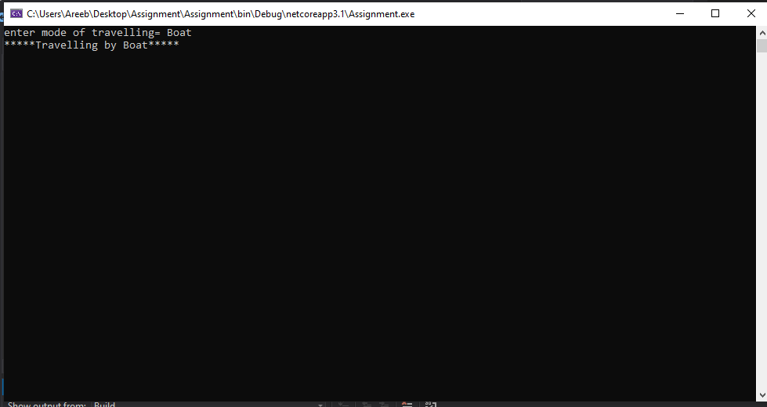

**Q3:**

**Code:**

using System;

namespace Assignment

{

public abstract class Modes

{

public abstract void TRAVELBY();

public void REFULE()

{

Console.WriteLine("REFUEL COMPLETE");

}

}

public class Car : Modes

{

public override void TRAVELBY()

{

Console.WriteLine("*****Travelling by Car*****");

}

}

public class Airplane : Modes

{

public override void TRAVELBY()

{

Console.WriteLine("*****Travelling by Airplane*****");

}

}

public class Boat : Modes

{

public override void TRAVELBY()

{

Console.WriteLine("*****Travelling by Boat*****");

}

}

class Program

{

static void Main(string[] args)

{

Console.Write("enter mode of travelling= ");

string choice = Console.ReadLine();

Modes mode;

if (choice == "BOAT" || choice == "boat")

{

mode = new Boat();

mode.TRAVELBY();

mode.REFULE();

}

else if (choice == "CAR" || choice == "car")

{

mode = new Car();

mode.TRAVELBY();

mode.REFULE();

}

else if (choice == "AIRPLANE" || choice == "airplane")

{

mode = new Airplane();

mode.TRAVELBY();

mode.REFULE();

}

Console.ReadKey();

}

}

}

**OUTPUT:**

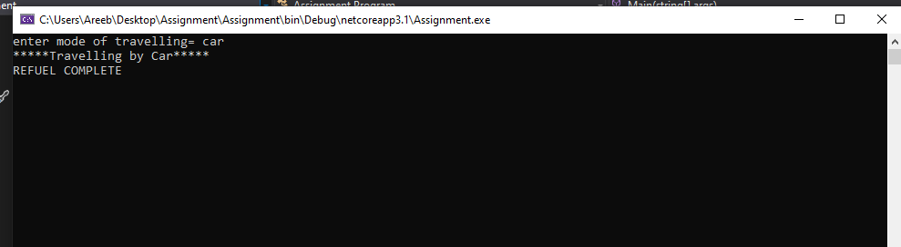

**Q4:**

**Code:**

using System;

namespace Assignment

{

class Program

{

static void Main(string[] args)

{

Student sT = new Student("UNDERGRADUATE");

Console.WriteLine("STUDENT");

sT.FirstName();

sT.LastName();

sT.Students();

Console.WriteLine("\n");

Professor pF = new Professor("20$");

Console.WriteLine("PROFESSOR");

pF.FirstName();

pF.LastName();

pF.salary();

Console.ReadLine();

}

}

interface Person

{

void FirstName();

void LastName();

}

public class Student : Person

{

public string Major;

public Student(string major)

{

this.Major = major;

}

public void FirstName()

{

Console.WriteLine("=====MUHAMMAD=====");

}

public void LastName()

{

Console.WriteLine("=====AREEB=====");

}

public void Students()

{

Console.WriteLine("=====STUDENTS MAJOR IS=====" + Major);

}

}

public class Professor : Person

{

public string Salary;

public Professor(string Salry)

{

this.Salary = Salry;

}

public void FirstName()

{

Console.WriteLine("=====ALI=====");

}

public void LastName()

{

Console.WriteLine("=====AHMED=====");

}

public void salary()

{

Console.WriteLine("professor salary is===" + Salary);

}

}

}

**OUTPUT:**

